**Model View Controller(MVC) Architecture Pattern :**

CricWare follows the widely known MVC (Model-View-Controller) architectural pattern as the system architecture. Below is the general diagram for the MVC architectural pattern.

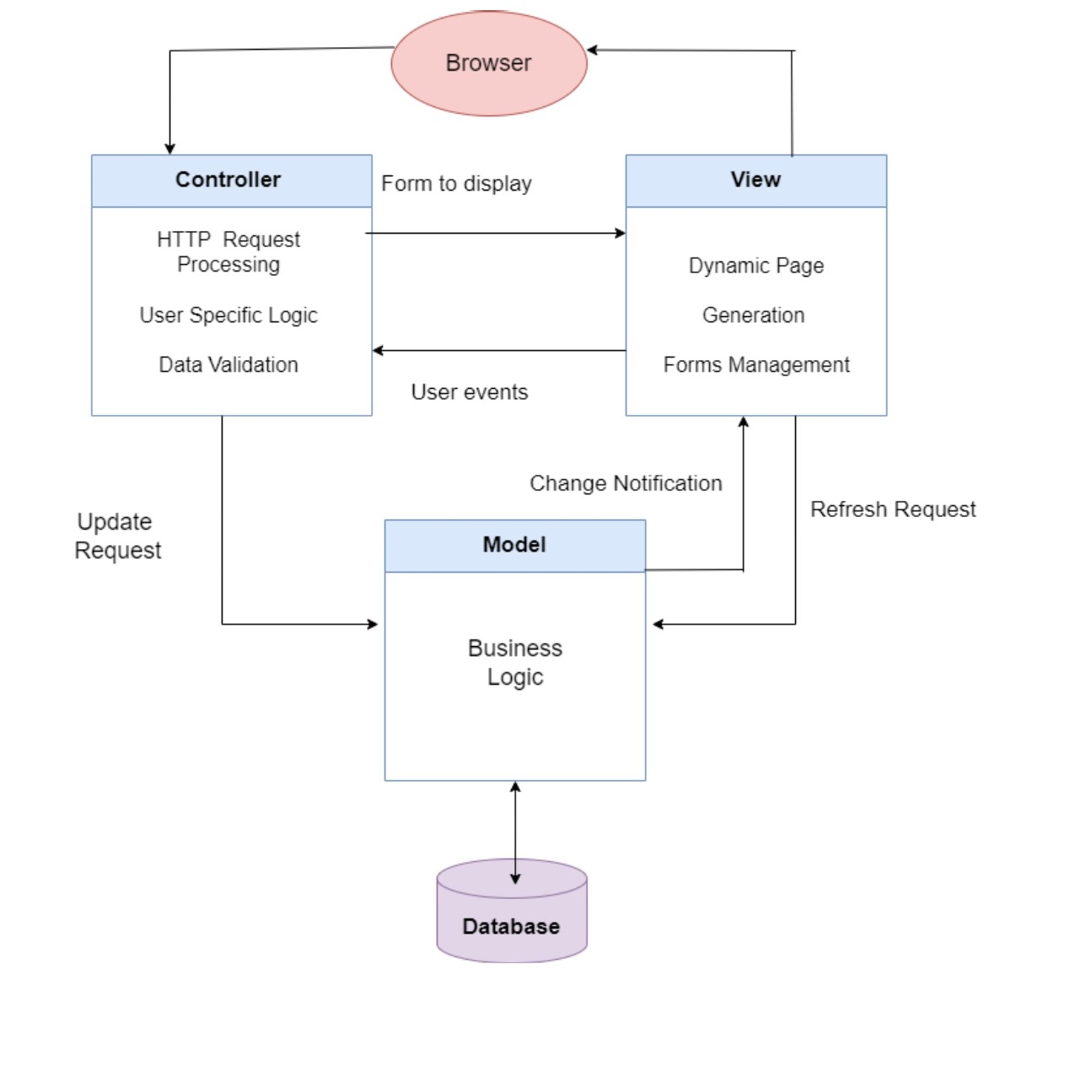

**1. Model:** The Model in CricWare would include classes or structures defining entities like User, Task, Payment, and functions/methods to interact with these entities, perform validations, and manage the data flow.

**2. View:** User interface components such as web pages, forms, and elements displaying task details, profile information, application forms, and messaging systems would be part of the View in CricWare.

**3. Controller:** In CricWare, controllers would include backend logic or server-side scripts that handle HTTP requests, validate input, trigger operations on the Model (e.g., posting a task, processing a job application), and render the appropriate View responses.